1. Create a S3 a bucket.

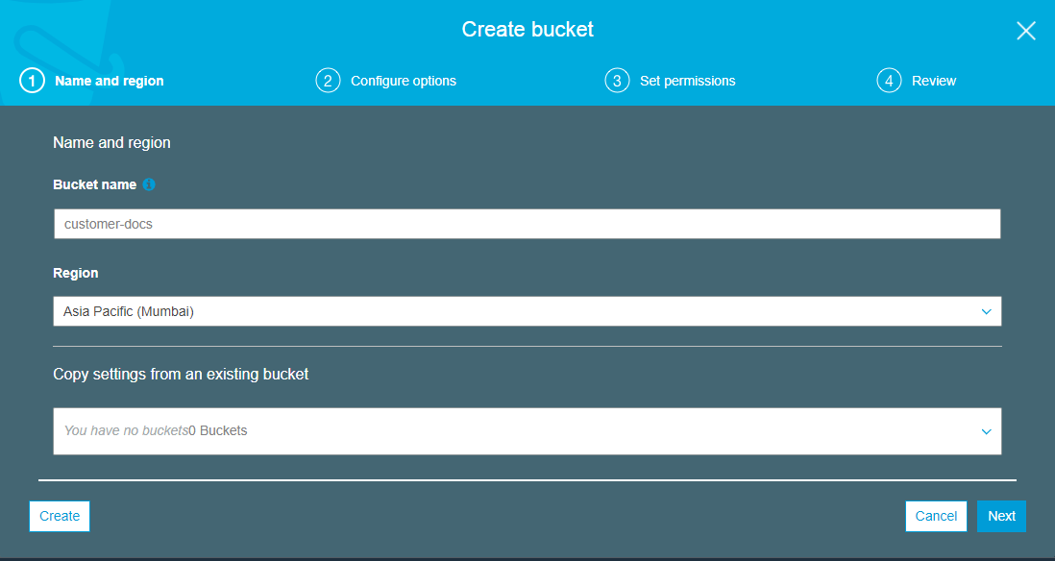

1. Block public access. Or make it private

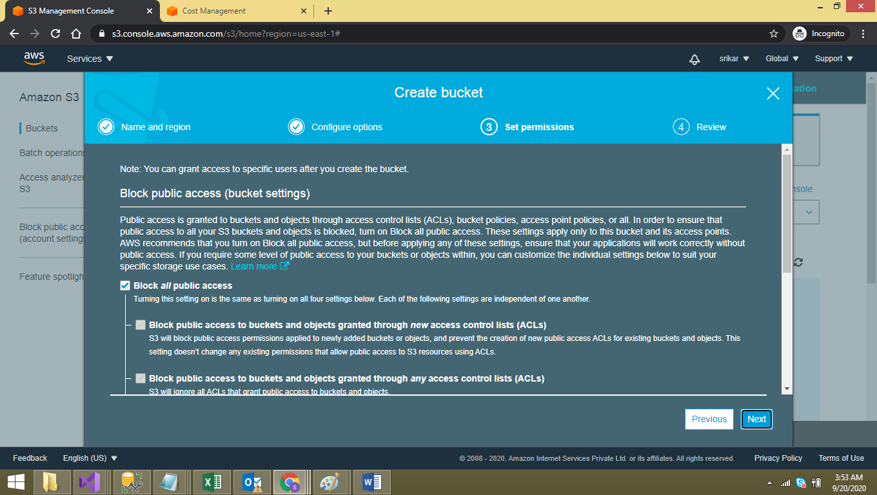

1. Add IAM user with Programmatic access.

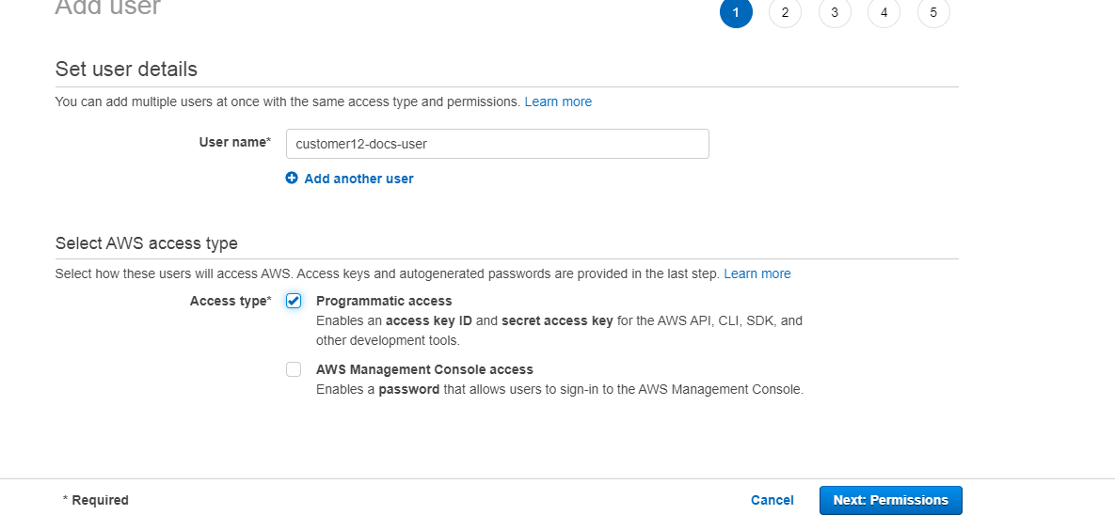

1. Attach existing S3 policies to the user.

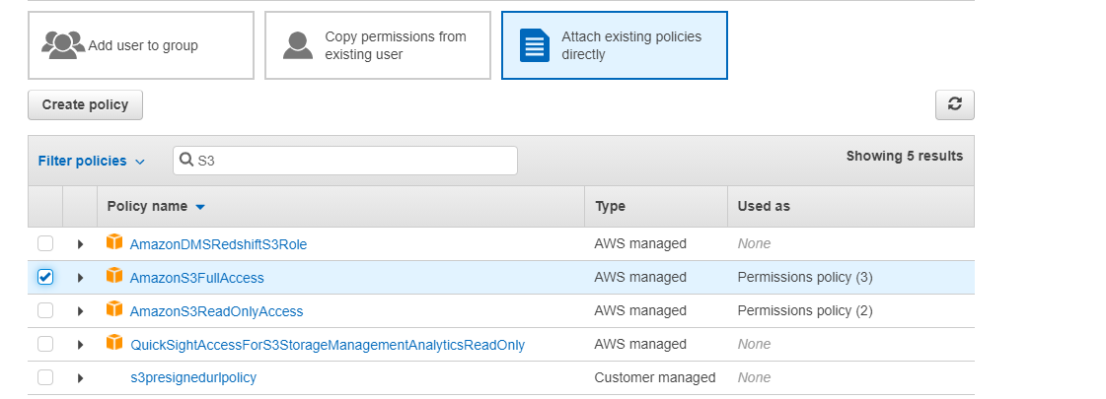

1. Download the user credentials.

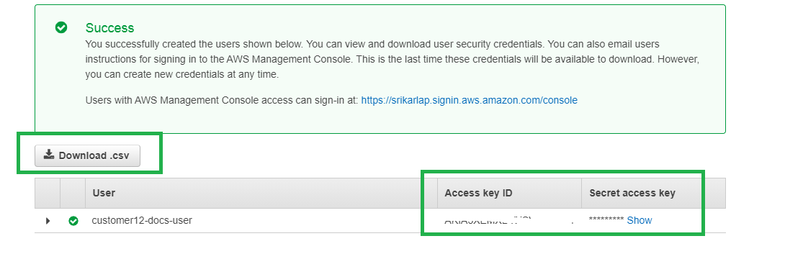

1. Validate the user credentials using AWS Cli for this step 1st you need to update credentials in “c:\Users\<<User Name>>\.aws\credentials” as follows.

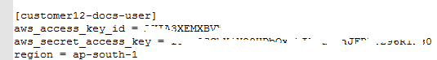.

1. Connect to AWS S3 using AWS cli and the profile updated in the step 6.

